EMJOS Sprint O Training

at

Nottingham Trent University (Clifton Campus) and

Clifton estates

on

Saturday 18th August

The format for the day will be to give you a good number of opportunities to specifically practise your Sprint Orienteering. Since there are only a few sprint races in the calendar then there is a risk of not specifically looking at what skills and techniques we need to use to maximise our Sprint O.

In the morning we'll be doing training around one of the Clifton estates, this was specially mapped by Dave Schorah for one of the British Sprint Squad training sessions (see extract left 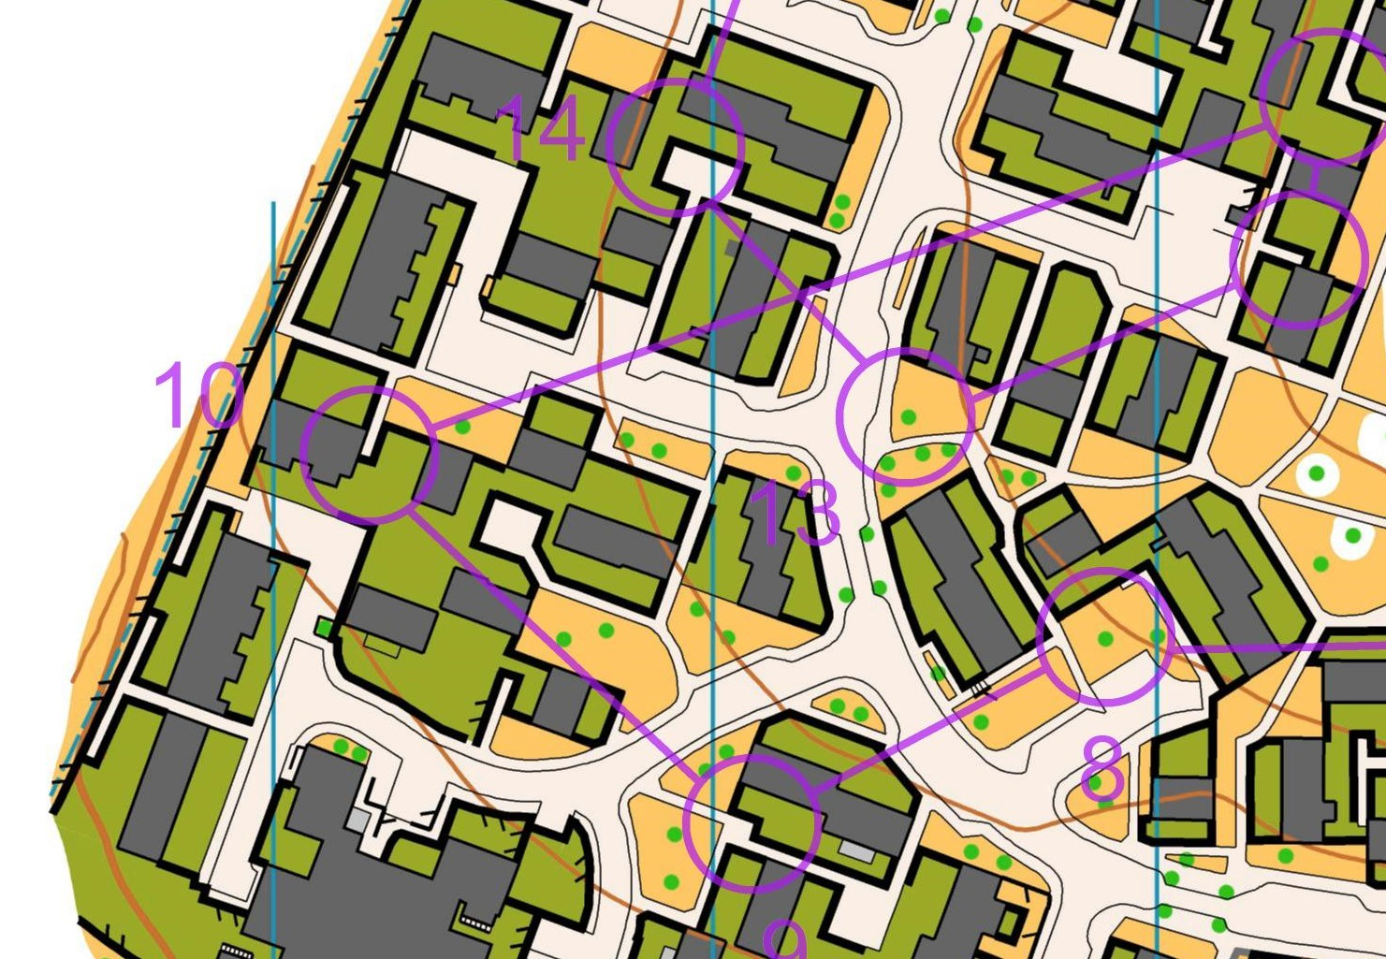) and we have the training exercises too, so you'll be following in the footsteps of our GB Sprint Stars.

In the afternoon we'll have a Level D Sprint event at NTU Campus - there will be up to 3 sprint courses for you to practise your sprint race routine; making the key route choice decisions and executing them.

Training is open to juniors and adults as the urban/campus areas have slowed traffic movements.

10:15am meet at NTU car park before walking over into the estate at 10:30am.

Lunch, followed by the NOC sprint event on the campus in the afternoon.

If you are interested in coming to the training: contact Ann-Marie Duckworth by email ([jasrduckworth@btinternet.com](mailto:jasrduckworth@btinternet.com)) by **Friday 10th August** to reserve your place.

As a reminder there is the LOG **Lincoln Urban Race** on Sunday (19th) - details here: http://www.logonline.org.uk/wp/lincoln-city-race-19th-august-2018/